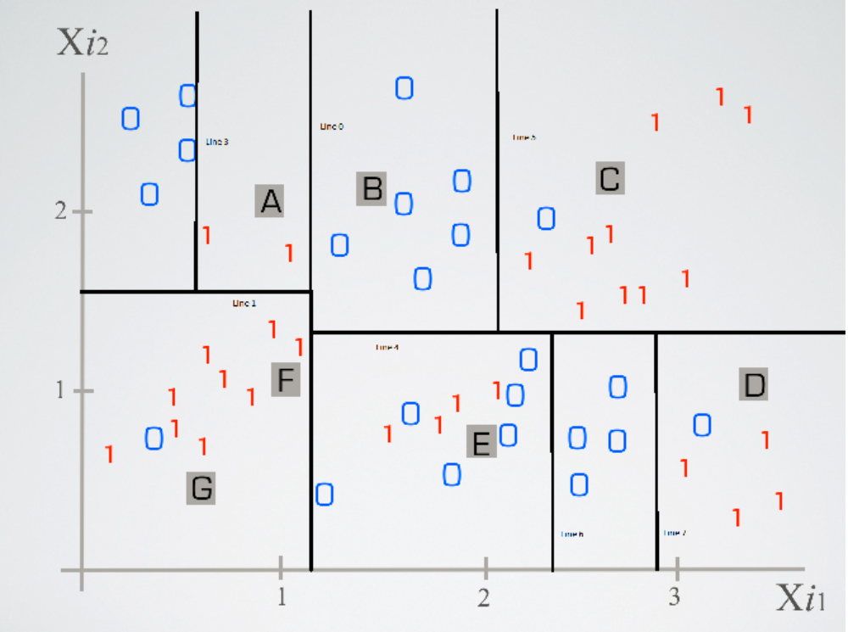
Legal Analytics Problem Set 2: Question 1

A = 1

B = 0

C = 1

D = 1

E = 0

F = 1

G = 1

